Multiple Random Variables

Locating the Key-Click Radio

Team: MCCCXXXVII

Team Leader: Colin Fischer

Team Members: Mike Doran, Carlos Lazo, Carolyn Andrews

Course: TDC1

Instructor: Karl Brommer

Group Hours: 16

Date Submitted: 10/24/2008

Executive Summary

Problem
Over the past month, our team, Team MCCCXXXVII, has developed a software patch for Blackhawk helicopters to detect paramilitaries communicating using key-click High Frequency (HF) radios. Now that we can successfully identify the radios; our customer, Sideband ANTennA (SANTA), has requested that we now quickly develop a system for locating the radios. They need to locate all key-click radios by early December.

Method of Analysis
In this project we will be leveraging knowledge gained from previous projects. In past projects, we have developed software for identifying HF Sideband Radios. In this project, we will create a new software patch that post processes data from two helicopters that had been sent out to listen for key clicks. Key clicks are the signature signals of the HF Sideband Radios. Each helicopter will record received time and Doppler shifted replica signals, s₁ and s₂, embedded in noise, where s₂ has a time shift, τ.

There will be a Time Difference of Arrival (TDOA) error since we will not be able to identify the exact location of the helicopter at any given point in time. We will also have a Frequency Difference of Arrival (FDOA) error since the helicopter velocity is constantly changing. Each of these errors is assumed independent and follows a Gaussian distribution. This means that we will have errors in perceived time shift and perceived frequency. When we calculate our overall variance for time shift and frequency as well as the joint probability density function of the error we will be able to predict the location of the radio with a degree of confidence.

Results / Recommendations
Our software patch can successfully identify the location of the radio with 95% accuracy. We recommend that SANTA implements our software patch as soon as possible to meet their early December deadline of locating all of the key-click radio users.

Table of Contents
Executive Summary 2
Problem 2
Method of Analysis 2
Results / Recommendations 2
Problem Statement 4
Overview 4
System Description 4
Assumptions 4
System Analysis 5
Approach 5
Detailed Analysis 5
Results 10
Results 10
Recommendations 10
References 11
Appendix 12

List of Figures

Figure 1: Helicopter Flight Pattern 4
Figure 2 - CAF Error Analysis 7
Figure 3 - 95% Confidence Interval 8
Figure 4 - CAF Accuracy when TDOA and FDOA intersect at a 45 degree angle 9

List of Tables
Table 1: Components of Error for TDOA Error Analysis 6
Table 2: Components of Error for FDOA Error Analysis 6
Table 3: Summary of Results 10

Nomenclature
Symbol | Definition | Units
τ | Time Difference | Seconds (s)
σ | Standard Deviation | ---
σ² | Variance | ---
f | Frequency Difference | Hertz (Hz)
A(τ,f) | Cross Ambiguity Function | ---
t | Time | s
λ | Wavelength | Meter (m)
α | Sweep Rate | Radian/s

Problem Statement

Overview
Our team has developed a software patch to locate enemy HF radios for use on Blackhawk helicopters. We have successfully developed a patch that can identify when a HF key-click radio is being used by paramilitaries. SANTA would like to be able to identify the location these radios so they can differentiate between naughty and nice children. Use of a key-click radio is associated with naughty children. Those who use the key-click radio will get coal in their stockings come December.

SANTA is currently using Blackhawk helicopters to monitor key-click radio activity. They would like to update the software to detect location of these radios as well. SANTA has acquired a radio from the foreign paramilitary that our team can use for testing. We will develop a Time Difference of Arrival/Frequency Difference of Arrival (TDOA/FDOA) system to locate the radios. Our software patch will take recordings from the radios currently deployed and post-process the data. We will analyze our software patch to predict the accuracy of our location processor.

System Description
Our system consists of two Blackhawk helicopters circling trying to locate enemy key click radios. These helicopters are equipped with a detection system that utilizes a patch we previously developed. We are adding another piece of software to the system which will post process the data after the helicopters return from their mission. This software will utilize a TDOA and a FDOA location algorithm to locate the position of the key click radios. Figure ______ shows how the helicopters will circle to locate the radios and how our algorithm will post process the data. CARLOS CHECK THIS AND ADD YOUR DRAWING PLEASE!

Figure 1: Helicopter Flight Pattern

Assumptions
- FDOA and TDOA are assumed to be independent following a Gaussian distribution.
  - This was leveraged from existing knowledge
- Near the intersection of the TDOA and FDOA the TDOA error can be approximated as linear
  - This can be assumed since the TDOA has such a large radius and error region is very small in comparison

System Analysis

Approach

The basic key click signal was calculated in a previous BAE SYSTEMS project. Our team is leveraging that project and searching for the signal using two helicopters. Two helicopters scan for the signal resulting in two received time and Doppler shifted replica signals, s₁ and s₂, embedded in noise, where s₂ has a time shift, τ.
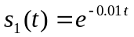 Equation 1
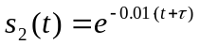 Equation 2
The Cross Ambiguity Function (CAF) is used to detect and locate the signal. There is error associated with receiving the signal due to helicopter position, time difference of arrival (TDOA) for the signal, helicopter velocity, and frequency difference of arrival (FDOA). Each error is assumed independent and follows a Gaussian distribution. This results in error in both the perceived τ and the frequency. By calculating overall variance for τ and frequency as well as the joint probability density function of the error it is possible to predict the emitter location with some confidence level.

Detailed Analysis

Equation 3 is the CAF for detecting and locating the signal.

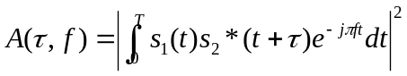 Equation 3

CAF Equation

Two platforms must be used for the CAF to work. The CAF uses the signal received by each platform (s₁, s₂) described by Equations 1 and 2. By combining the two signals through convolution and comparing each signal as the helicopters move it is possible to locate the signal. The CAF is calculated numerically and plotted using Matlab.

PLOT CDF

The CDF A, is plotted vs. τ and frequency. The maximum (τ *, f*) of the CDF can be seen in figure ____ .

There is error associated with the time delay measurement, τ, of the signal. This error is a result of error in helicopter position error as well as error in the pulse time delay estimate. These errors are independent Gaussian random variables. The errors have a variance shown in Table 1.

Table 1: Components of Error for TDOA Error Analysis
Component of Error | Variance
Helicopter position error | 2σ²_{p}
Pulse time delay estimate | σ²_{TDOA}

σ_{p} is the typical uncertainty in helicopter position along one dimension. σ_{TDOA} is the typical uncertainty in pulse time of arrival measurement. The variance of the time delay measurement can be calculated by summing the variance of the components of error.

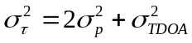 Equation 4

The probability density for τ, p(τ) is Gaussian and can be written in terms of the error variances.

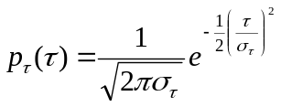 Equation 5

The error in the FDOA is calculated following a similar method as the TDOA; however there are more components for error. Table 2 shows the components for error.

Table 2: Components of Error for FDOA Error Analysis
Component of Error | Variance
Helicopter position error | α²σ²_{p}/λ²
Pulse differential Doppler estimate | σ²_{FDOA}
Helicopter velocity | 2σ²_{v}

σ_{v} is the typical uncertainty in helicopter position along one dimension. α is the angular sweep rate of the helicopter with respect to the emitter. σ_{FDOA} is the typical uncertainty in pulse differential frequency measurement. In order to calculate the probability density, p(f), for the FDOA measurement we first must calculate the frequency variance. Equation 6 shows that the frequency variance is a function of the variance for each component of error.
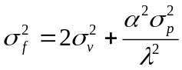 Equation 6

The p_{f}(f) is a Gaussian function that depends on the variance of the frequency as shown in Equation 7.

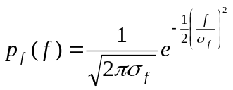 Equation 7

The accuracy of the CAF function is based on the standard deviations due to TDOA error and FDOA error derived previously. In this analysis we assume that the TDOA is perpendicular to the FDOA as seen in Figure 2.

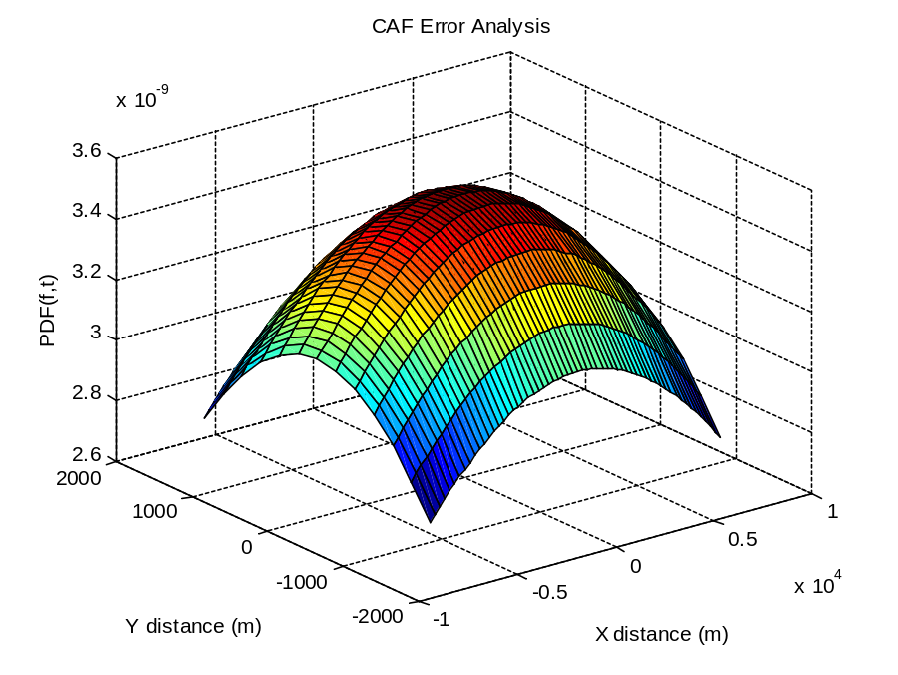
Figure 2 - CAF Error Analysis

The standard deviation of the TDOA, σ_{τ}, is equal to the TDOA line width. A coworker that has been working this project as an Internal Research and Development (IRAD) has supplied the TDOA value, 15km. Plugging this value into Equation 5 yields the probability density function of the TDOA. The standard deviation of the FDOA, σ_{f}, is equal to the FDOA line width, shown in Figure ______. The same individual has supplied our team with the FDOA line width, 3km. Once again this value can be plugged into Equation 7 to give us the probability density function of the FDOA.

As mentioned previously, the FDOA and TDOA errors are independent random variables following a Gaussian probability density function. The CAF accuracy can be found by multiplying the two density functions together as seen in Equation 8.

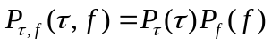 Equation 8

Using Matlab the CAF Accuracy equation can be plotted versus τ and f. Since the plot depends on two Gaussian distributed functions it will result in a mountain shaped plot.

Perfect accuracy is very expensive to obtain. Although BAE SYSTEMS strives for perfection our customer has asked for a 95% confidence in our result. The 95% confidence interval is the area within two standard deviations of the mean of the CAF. The confidence range yields an elliptical result that can be seen in Figure 3.

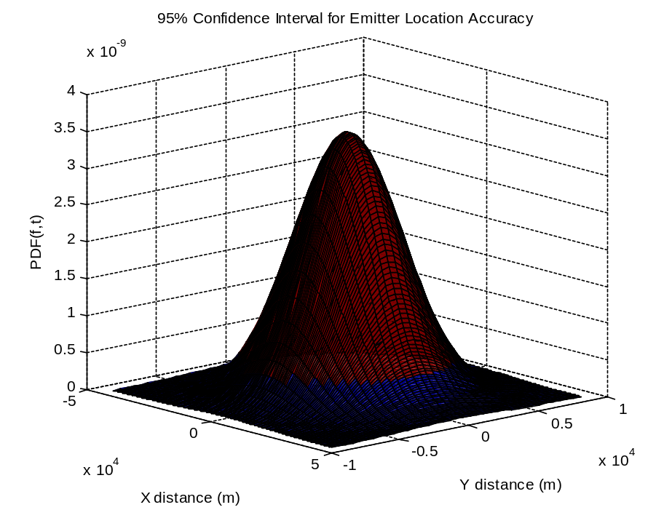
Figure 3 - 95% Confidence Interval

The system up to this point required the TDOA to be perpendicular to the FDOA. However, helicopters move around and the lines of the TDOA and FDOA will rarely be perpendicular to each other. This will cause the shape of the joint probability function to change depending on the angle between the TDOA and FDOA. In addition to the system working when the TDOA and FDOA are perpendicular, our customer has asked that our system can detect an antenna when the TDOA and FDOA are at 45 degree angles of each other. CARLOS WRITE THIS IN ENGLISH PLEASE
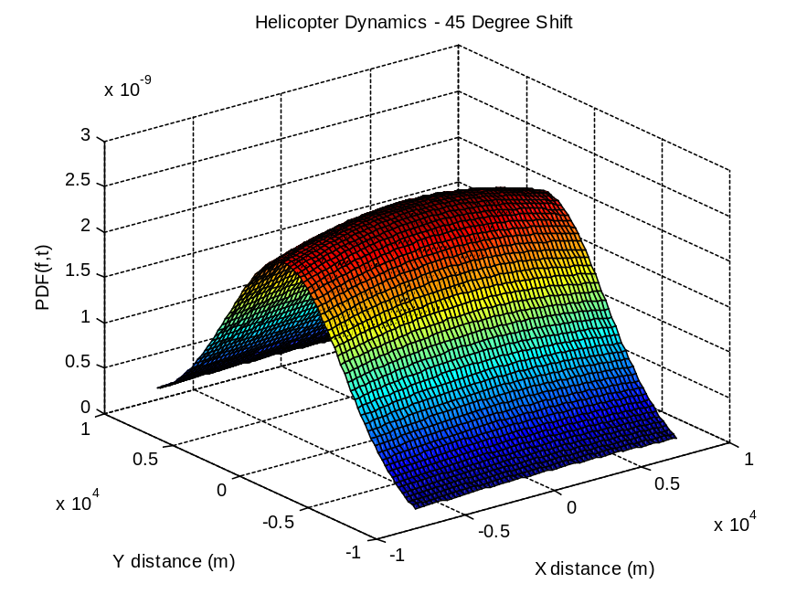
Figure 4 - CAF Accuracy when TDOA and FDOA intersect at a 45 degree angle

The system location accuracy performance could be improved by allowing repeated dwells on the same pulses as the helicopters sweep in a pattern. The helicopter will send out multiple pings of the key click radio and then compare the new signal response to the previously received signal. Pin point accuracy could be obtained using this method if the sample size was large enough. For a calculation made using N samples, the overall error drops by a factor of 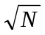. Pin point accuracy could also be obtained using a single helicopter if it were sampling at an extremely high rate. Besides an improvement due to the number of samples, because the helicopters are moving, the TDOA and FDOA lines used to determine the radio location are rotating. By looking at several rotations of lines, we are able to bring the edges of our distribution closer to the center. This allows for further increase in accuracy.

Results

Results

Table 3: Summary of Results

Recommendations
SANTA should implement our software patch. Once implemented, our patch will allow SANTA to locate every key-click radio in just a few months. This will allow SANTA to meet their early December deadline of identifying every key-click radio owner.

References

Appendix

Matlab Code:

